MECARMY

PT Series User Manual

Ultra Bright USB Rechargeable Compact Flashlight
Primary Features
- Patented Product
- Ultra bright Compact flashlight with USB rechargeable function
- Uses 3 CREE XP-G2 LEDs, lifespan up to 50,000 hours
- Momentary ON function
- Instant access to Turbo/Strobe
- Uses rechargeable lithium ion battery
- Quick recharge
- Standard Micro USB Charging port, charges on any USB port
- Charging and fully charged indicators
- Electronic side switch design, easy to change modes
- Wide voltage range circuit design
- Over-heat protection to avoid high-temperature of the surface
- Reverse polarity protection prevents damage from an incorrectly inserted battery
- Rugged pineapple texture for grip and anti-roll
- Constructed from aero grade aluminum alloy, with HAIII hard-anodized
- Tail stand capability
- IPX-8 water resistance

PT10 Specification

Emitter:: 3×CREE XP-G2 LED
Output& Runtime
Mode/ Specification | Turbo | Low | Med | High | Strobe | SOS
Output (Lumens) | 800 | 10 | 100 | 320 | 800 | 800
Runtime | 18mins | 17h | 85mins | 25mins | / | /
Peak beam intensity | 4013cd
Max beam distance | 126m
Impact resistance | 1.5m
Waterproof | IPX8 (underwater 2 meters)

- Dimensions
Length：77mm/3.03in
Head dimension：30mm/1.18in
Body dimension：16mm/0.63in
- Weight：58.5g/2.06oz (Excluding battery)
- Battery：10440 Li-ion battery
- Working voltage：2.5V-8.4V
- Charging time: 90 minutes (charging current 300mA)
- Accessory：User manual, 1×10440 Battery, O-ring, lanyard

PT14 Specification

Emitter:: 3×CREE XP-G2 LED
Mode/ Specification | Turbo | Low | Med | High | Strobe | SOS
Output (Lumens) | 900 | 10 | 100 | 330 | 900 | 900
Runtime | 43mins | 45h | 4.2h | 1.1h | / | /
Peakbeam intensity | 4369cd
Max beam distance | 132m
Impact resistance | 1.5m
Waterproof | IPX8 (underwater 2 meters)

- Dimensions
Length：84mm/3.31in
Head dimension：30mm/1.18in
Body dimension：20mm/0.79in
- Weight：63.2g/2.23oz (Excluding battery)
- Battery：14500 Li-ion battery
- Working voltage：2.5V-8.4V
- Charging time: 90 minutes (charging current 600mA)
- Accessory：User manual, 1×14500 Battery, O-ring, lanyard

PT16 Specification

Emitter:: 3×CREE XP-G2 LED
Mode/ Specification | Turbo | Low | Med | High | Strobe | SOS
Output (Lumens) | 1000 | 5 | 100 | 420 | 1000 | 1000
Runtime | 35mins | 20h | 4h | 1h | / | /
Peak beam intensity | 4915cd
Max beam distance | 140m
Impact resistance | 1.5m
Waterproof | IPX8 (underwater 2 meters)

- Dimensions
Length：67.5mm/2.66in
Head dimension：30mm/1.18in
Body dimension：22.5mm/0.89in
- Weight：40g/1.41oz (Excluding battery)
- Battery：16340 Li-ion battery(brightness and efficiency will be lower with CR123A battery)
- Working voltage：2.5V-8.4V
- Charging time: 90 minutes (charging current 600mA)
- Accessory：User manual, 1×16340 Battery, O-ring, lanyard

PT18 Specification

Emitter:: 3×CREE XP-G2 LED
Mode/ Specification | Turbo | Low | Med | High | Strobe | SOS
Output (Lumens) | 1000 | 10 | 100 | 330 | 1000 | 1000
Runtime | 2.8h | 156h | 16.5h | 4h | / | /
Peak beam intensity | 4915cd
Max beam distance | 140m
Impact resistance | 1.5m
Waterproof | IPX8 (underwater 2 meters)

- Dimensions
Length：103mm/4.06in
Head dimension：30mm/1.18in
Body dimension：22mm/0.87in
- Weight：60g/2.12oz (Excluding battery)
- Battery：18650 Li-ion battery
- Working voltage：2.5V-8.4V
- Charging time: 3 hours (charging current 1000mA)
- Accessory：User manual, 1×18650 Battery, O-ring, lanyard

NOTICE: The above-mentioned parameters are approximate and may vary between flashlights, batteries and environments.

Operation
- From OFF: 1 click for ON (Low mode)
- From OFF: 2 click for Turbo
- From OFF: 3 click for STROBE
- From STROBE: Long press (> 1 second) for SOS
- From OFF: Press and hold for Momentary ON (Turbo), release to turn off
- From ON: 1 click for OFF
- From ON: Press and hold to cycle through modes (Low/Med/High/Turbo)

Turbo Mode: In Turbo mode the 3 CREE XP-G2 LEDs run at the highest brightness and discharge rate. High quality batteries are recommended for peak performance.

The PT series is a high-performance light and generates significant heat in Turbo mode. To protect the light and user, output in Turbo will drop to 70% of maximum brightness after 3 minutes. Output will also be adjusted by real time temperature monitoring

Charging
Carefully unscrew and remove the light’s head, and connect a mini USB charging cable as shown in the diagram below

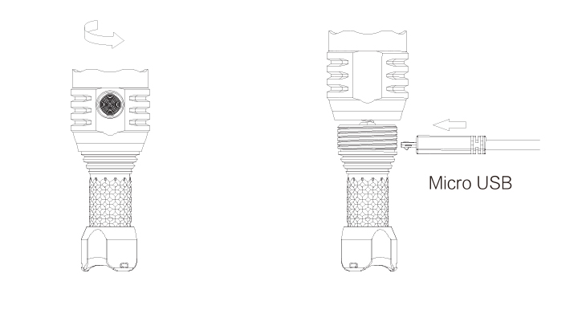
Charging Indicator
When charging, the indicator light turns red, when charging is complete, the indicator light turns green
No indicator light indicates that there is no load

WARNING:
- Do not point the light at human or animal eyes
- Do not look directly into the light when it is switched on
- Do not permit children to use the flashlight unsupervised

Maintenance
- Remove battery when stored for extended periods
- Replace and lubricate O-Rings as needed to maintain IPX-8 rating
- Every 6 months, thread should be wiped with a clean cloth followed by a thin coating of silicon-based lubricant

Warranty Service
- Guaranteed exchange up to 15 days after purchase: any defective product can be exchanged for a replacement through a local distributor/dealer within 15 days
- After 15 days: all defective products can be repaired free of charge for a period of 5 years from the date of purchase
- Lifetime workmanship guarantee: after the free maintenance period has expired, the maintenance service will charge for material expenses only, free of labor expenses.

ALTUN LIMITED

TEL: +86-755-23764109

FAX: +86-755-23760255

E-mail: info@mecarmy.com

Web: www.MecArmy.com

Address: Yikang Mansion, Huarong Road, Dalang Street, Longhua District, Shenzhen, China

